Mr. Hamilton
Point Grey Mini School
Humanities 10
In Context of the New Curriculum

“The redesigned curricula for English and Social Studies will support disciplinary and interdisciplinary learning, encourage locally-developed curriculum, as well as enable a variety of learning environments and school configurations. This flexibility supports teachers and students wanting to organize learning through interdisciplinary inquiries that focus on project-based and problem-based learning.” –context document, Provincial Curriculum and Assessment Framework Advisory Group
This year and the next we will study in a transitional framing of the new curriculum’s content. Because of the design and the pedagogy of the Humanities courses, much of the curricular competencies of this ‘re-imagined’/new curriculum are already well-ingrained in this Mini course. This is an exciting time to be a student, and to be a student at PG Mini!
Humanities is a blended course and over the course of your two years in the new curriculum, you will get course credit for Social Studies 9 and 10, English 9, Focused Literature 10 (2 credits) and Composition 10 (2 credits)
- The historical focus for our course is “Canada and the World: 1919 to present”
- Our thematic topics centre on active citizenship and developing a sense of what it means to be Canadian in the past, present and future
- The focus of the literature will support our Socials Studies content

BIG IDEAS for Socials Studies
- Global and regional conflicts have been a powerful force in shaping our contemporary world and identities.
- The development of political institutions is influenced by economic, social, ideological, and geographic factors.
- Worldviews lead to different perspectives and ideas about developments in Canadian society.
- Historical and contemporary injustices challenge the narrative and identity of Canada as an inclusive, multicultural society.
Learning Standards for Social Studies 10
Curricular Competencies  Students are expected to be able to do the following:  • Use Social Studies inquiry processes and skills to ask questions; gather, interpret, and analyze ideas; and communicate findings and decisions • Assess the significance of people, places, events, or developments, and compare varying perspectives on their significance at particular times and places, and from group to group (significance)  • Assess the justification for competing accounts after investigating points of contention, reliability of sources, and adequacy of evidence (evidence)  • Compare and contrast continuities and changes for different groups during this period (continuity and change)  • Assess how prevailing conditions and the actions of individuals or groups influence events, decisions, or developments (cause and consequence)  • Explain and infer different perspectives on past or present people, places, issues, or events by considering prevailing norms, values, worldviews, and beliefs (perspective)  • Recognize implicit and explicit ethical judgments in a variety of sources (ethical judgment)  • Make reasoned ethical judgments about actions in the past and present, and determine appropriate ways to remember and respond (ethical judgment) | Content  Students are expected to know the following:  • development, structure, and function of Canadian and other political institutions, including First Peoples governance  • political and economic ideologies and the development of public policy  • changing conceptions of identity in Canada  • Canadian autonomy  • domestic conflict and co-operation  • discriminatory policies and injustices in Canada and the world, such as the Head Tax, the Komagata Maru incident, residential schools, and internments  • international conflicts and co-operation • human–environment interaction  • economic development and Canada’s role in a global economy  • truth and reconciliation in Canada

Big Ideas for Focused Literature and Composition
- The exploration of text and story deepens our understanding of diverse, complex ideas about identity, others, and the world.
- People understand text differently depending on their worldviews and perspectives.
- Texts are socially, culturally, geographically, and historically constructed.
- Language shapes ideas and influences others.
- Questioning what we hear, read, and view contributes to our ability to be educated and engaged citizens.

Learning Standards for Literature and Composition 10
Curricular Competencies | Content
Using oral, written, visual, and digital texts, students are expected individually and collaboratively to be able to: | Students are expected to know the following:
Comprehend and connect (reading, listening, viewing)  - Read for enjoyment and to achieve personal goals  - Recognize and appreciate the role of story, narrative, and oral tradition in expressing First Peoples perspectives, values, beliefs, and points of view  - Recognize the diversity within and across First Peoples societies represented in texts  - Access information for diverse purposes and from a variety of sources and evaluate its relevance, accuracy, and reliability  - Apply appropriate strategies in a variety of contexts to comprehend written, oral, visual, and multimodal texts; guide inquiry; and extend thinking  - Synthesize ideas from a variety of texts/sources  - Recognize and appreciate how various forms, structures, and features of texts reflect a variety of purposes, audiences, and messages  - Think critically, creatively, and reflectively to explore ideas within, between, and beyond texts  - Recognize and identify the role of personal, social, and cultural contexts, values, and perspectives in texts  - Recognize how language constructs personal, social, and cultural identity  - Construct meaningful personal connections between self, text, and world  - Respond to text in personal, creative, and critical ways  - Evaluate how literary elements, techniques, and devices enhance and shape meaning and impact  Create and communicate (writing, speaking, representing)  - Respectfully exchange ideas and viewpoints from diverse perspectives to build shared understanding and extend thinking  - Demonstrate speaking and listening skills in a variety of formal and informal contexts for a range of purposes  - Use writing and design processes to plan, develop, and create engaging and meaningful literary, imaginative, and informational texts for a variety of purposes and audiences  - Express and support an opinion with credible evidence  - Reflect on, assess, and refine texts to improve their clarity, effectiveness, and impact according to purpose, audience, and message  - Use the conventions of Canadian spelling, grammar, and punctuation proficiently and as appropriate to the context  - Use acknowledgements and citations to recognize intellectual property rights | Text features and structures  • features and structures of First Peoples text:  — narrative structures found in First Peoples  texts  — issues related to the ownership of First  Peoples texts, and protocols for their use  — the legal status of First Peoples oral tradition  in Canada  Writer’s craft  • characteristics of writers  • voices, styles, and perspectives  • writing as a process  • authentic audiences and real-world purposes  Writing genres  • forms of written communication  • relationship between form and function  • different purposes  • formats  Writing style  • literary techniques and devices  • stylistic choices  • techniques of specific genres

Point Grey Mini School
Mr. Hamilton
Humanities 10 Syllabus

Please note that the ‘suggested resources are just that; these resources may be used in part or in entirety as well as supplemented with additional resources not listed. Humanities 10 is meant to be taken as the compliment course to Humanities 9. Students will get credit for both Socials 10 and English 9. Visit www.pghamilton.weebly.com for access to Mr. Hamilton’s Planbook, updates, evaluation rubrics and hand-outs.

Unit One: (2 weeks) The Writing Process in Practice
- Interview and Magazine Article Project

Unit Two: (2 weeks) The Laurier Boom
- Canadian liberalism and nation-building

Unit Three (3 weeks) The Great War
- Imperialism and Alliances
- The paradox of Vimy Ridge
- Three Day Road (excerpts)

Unit Four (1 week) The Russian Revolution
- Feurbach, Hegel, Marx and Engels: Philosophy of the Revolution

Unit Five (5 weeks) Animal Farm
- Aesop and the beast fable
- Building a Dictatorship: language and propaganda
- The Third Wave Experiment

Unit Six (2 weeks) The Interwar Period and Rise of Fascism
- Stalin and Hitler

Unit Seven (1 week) The Great Depression in Canada
- Drought, Populism and Social Welfare

Unit Eight (omit 2017-2018) To Kill A Mockingbird
- Poverty, Racism, and seeds of The Civil Rights Movement
- Gothicism and The Bildungsroman

Unit Nine (2 weeks) Canada and World War II- War Stories at home and abroad
- Japanese Internment and the Vancouver Asahi

Unit Ten (6 weeks) Indigenous Peoples and Canada
- Louis Riel, the Metis people, rebellion and Manitoba
- Residential Schooling and Truth and Reconciliation
- Indian Horse by Richard Wagamese
- Joseph Boyden and cultural identity

Field Studies
Humanities enrichment field studies and workshops at: Bard on the Beach, Vancouver International Writers’ Festival, Vancouver International Film Festival, Cinematheque media studies workshops, Oregon Shakespeare Festival and others…
Print Resources
Carrier, Roch. Our Life with the Rocket. Penguin Viking. 2001.
Cranny, Michael and Moles, Garvin. Counterpoints: Exploring Canadian Issues. Prentice Hall. 2001.
Gray, Charlotte. The Promise of Canada. Simon & Schuster. 2016.
Morton, Desmond. Towards Tomorrow: Canada in a Changing World. Harcourt. 1988.
Orwell, George. Animal Farm. Signet. 1996
Reynolds, Jim. Aboriginal People and the Law: A Critical Introduction. UBC. 2018
Wagamese, Richard. Indian Horse. Douglas & McIntyre. 2012.

Evaluation, Assessment and Expectations
Students will have opportunities to demonstrate competencies through a variety of tasks over the school year. At discretion of teacher, students may be asked to resubmit whole or part assignments until learning expectations are met. While students work towards those expectations, they will receive an “I” (in progress) grade on that task or part of task. Students will be asked to conference with teacher in tutorial or other time in order to give them the best opportunity to meet the task expectations in a timely fashion. For assessment purposes, these tasks and their weight are:
Assignments (including projects, reports, etc.) 55%
Tests and Quizzes 30%
Participation and Citizenship (this includes having homework completed and being willing to discuss topics in class) 15%
Expectations
1. Students are required to be in attendance
2. Assignments are to be submitted by the due date
3. A test or assignment missed by a student having a legitimate absence, may be written when the student delivers a parental note to the teacher.
4. Students experiencing difficulty must ask the teacher for extra help or learning assistance
5. Students will treat the room and furnishings with respect
6. Students will treat one another with respect

RESPECT AND RESPONSIBILITY
High school is one of the most exciting times of your life. Have fun.
“Be more concerned with your character than your reputation, because your character is what you really are, while your reputation is merely what others think you are.”

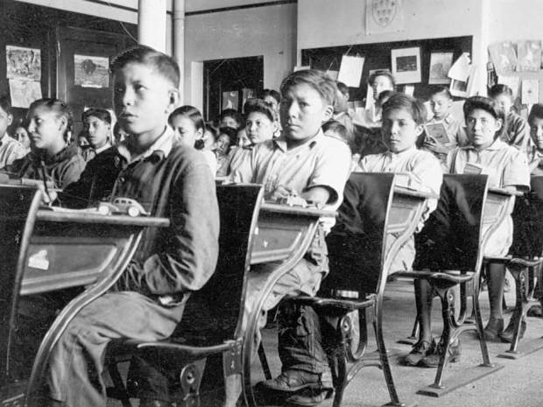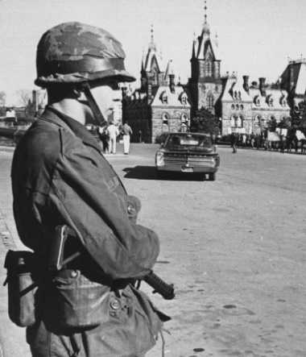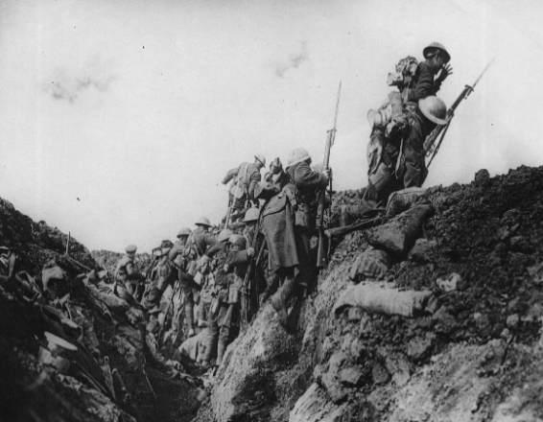

WW I with exerpts from 3 Day Road; Vimy Ridge (Canada becoming a nation...) Russian Revolution 1917 and Animal Farm: Information, Propaganda, Fascism Interwar Period to Great Depression (cursory in 2017-18): Excess, American Dream, Buying on Margin (link to 2008 and subprime mortgage crisis) Stalinist Soviet Union (Ukraine and Holodomor: 2017-2018 only): Assimilation, Genocide Rise of Fascism: Nazi Germany All the Light You Cannot See excerpts? The Wave and the Third Wave experiment To Kill a Mockingbird (omit 2017-2018): Racism, Poverty, Bildungsroman, Southern Gothicism Civil Rights Movement (omit 2017-18 Eyes on the Prize): Racism, Rights, Liberalism Contemporary Indigenous Issues + Residential Schoolings + Truth and Reconciliation, Racism, Rights, Liberalism; Joseph Boyden and Identity Indian Horse: Hockey, Identity, Assimilation, Exploitation, Racism WWII: Japanese Internment and Obasan? Identity, Assimilation, Exploitation, Racism Quebec and Quiet Revoution (My Life with the Rocket): Identity, Nationalism, Assimilation, Racism Canadian Identity, rise of social democracy: Tommy Douglas and Universal Health Care Pluralism and the challenges

Liberty is more than the absence of restraint, it must include equality of opportunity.

